Yuva Intern

Week 4 Technical Report
Strategic Agricultural Data Analysis and Agribusiness Recommendations for Improving Crop Yield and Operational Efficiency
Synthesis of exploratory analysis, data preprocessing and machine learning on the 2024-25 district-level crop dataset
Student | Atharv Vyahalkar
Internship role | Junior Machine Learning Data Analyst: Agriculture & Agribusiness
Academic year | 2026-27
Dataset | Crop Data 24-25 (district-level crop statistics, 2024-25)
Report | Week 4
Submission date | November 2026

Contents
Abstract 3
1. Introduction 3
1.1 Background 3
1.2 Data-driven decisions in agribusiness 3
1.3 Purpose and scope of this report 3
2. Project Objectives 4
3. Overview of the Four-Week Work 4
3.1 Workflow 4
3.2 Tools 5
3.3 Data source and provenance 5
4. Week 1 Summary: Exploratory Data Analysis 5
4.1 Dataset and data quality 5
4.2 Crop, state, district and seasonal patterns 5
4.3 Area, production and yield 6
4.4 Rainfall context 6
5. Week 2 Summary: Data Preprocessing 7
5.1 Missing values 7
5.2 Outlier analysis 7
5.3 Filtering to a modelling subset 7
5.4 Encoding and transformation 7
5.5 Limitations of the preprocessing 7
6. Week 3 Summary: Machine Learning Modelling 8
6.1 Problem formulation 8
6.2 Train-test split 8
6.3 Models and evaluation metrics 8
6.4 Hyperparameter tuning 9
6.5 Training and test performance 9
6.6 Feature importance 9
6.7 Error analysis and limitations 10
7. Integrated Findings and Interpretation 10
8. Agricultural and Agribusiness Challenges 11
9. Strategic Recommendations 11
9.1 Approach 11
9.2 Crop planning and crop selection 12
9.3 District-level yield monitoring 12
9.4 Agricultural data dashboards 12
9.5 Soil-health information 13
9.6 Weather-based planning 13
9.7 Irrigation and water management 13
9.8 Fertiliser and seed planning 14
9.9 Machinery and labour allocation 14
9.10 Procurement and supply-chain planning 14
9.11 Predictive analytics 15
10. Proposed Implementation Roadmap 15
11. Proposed Monitoring Framework and KPIs 16
11.1 Principles 16
11.2 Indicators 16
11.3 Oversight 17
12. Limitations 17
13. Future Scope 18
14. Conclusion 18
References 19

Abstract
This report completes a four-week project carried out under the Yuva Intern programme (Junior Machine Learning Data Analyst: Agriculture & Agribusiness). The project explored, prepared and modelled a district-level crop dataset for 2024-25 containing 25,239 records of area, production and yield, and Week 4 brings the three earlier stages together and considers what they imply for agribusiness decision-making.
Exploratory analysis (Week 1) showed that recorded yield differs strongly between crops and that area and production are strongly correlated (r ≈ 0.823, n = 10,134). Preprocessing (Week 2) removed 47 records with missing Production and Yield, excluded overlapping aggregate crop categories and Total-season records from the modelling subset, leaving 9,795 observations , and produced a 9,795 × 775 numerical matrix. In Week 3, five regression models were compared for estimating standardized yield from state, district, crop, season and area. A tuned Random Forest performed best on the held-out test set (MAE 0.2632, RMSE 0.4592, R² 0.7843), compared with RMSE 0.9891 for a mean-predicting baseline.
These results are subject to important limitations. Preprocessing was fitted before the train-test split, the split was random, only one agricultural year was available, and no weather, soil, irrigation, input, labour or market data were included. The model is therefore a same-season estimation exercise and not a validated forecasting or farm-level recommendation system. Ten agribusiness strategies are proposed, each tied to a specific finding or limitation of the project, with the additional data and indicators needed to test it. They are proposals for future validation and not tested outcomes.
Keywords: crop yield; exploratory data analysis; data preprocessing; Random Forest; agribusiness; decision support.

1. Introduction

1.1 Background
Agricultural planning depends on knowing how much of each crop is grown, where, and how productive the land is. Government statistics report area, production and yield by district, crop and season, but these tables are large, contain aggregate and individual categories side by side, and are rarely examined with analytical tools by the organisations that depend on them. The project described here used one such table, the 2024-25 district-level crop statistics, to practise a complete data-analysis workflow: exploration, preparation, modelling and interpretation.

1.2 Data-driven decisions in agribusiness
Agribusinesses make decisions about crop promotion, input supply, equipment and labour scheduling, procurement and storage under uncertainty. Systematic analysis does not remove that uncertainty, but it makes the evidence behind a decision explicit, shows where records are weak, and allows decisions to be reviewed against outcomes. The value of an analysis depends on how well its limits are understood, and this report therefore pays particular attention to what the project can and cannot support.

1.3 Purpose and scope of this report
Weeks 1 to 3 produced separate technical reports on exploratory analysis, preprocessing and machine learning. This report summarises that work, interprets it as a whole, and uses it to develop practical recommendations. Throughout, three kinds of statement are kept apart: observed findings, which are directly supported by the analysis performed; interpretations, which are reasonable explanations of those findings but were not tested; and proposed strategies, which are recommendations for future implementation and have not been tried. No part of the project measured the effect of any agricultural or business intervention.

2. Project Objectives
The project objectives were organised across four stages, covering exploratory data analysis, data preprocessing, machine learning modelling, and the integration of findings into strategic agribusiness recommendations.
- to explore the structure, quality and descriptive patterns of the 2024-25 crop dataset (Week 1).
- to prepare the data for machine learning through documented decisions on missing values, outliers, overlapping categories, encoding and transformation (Week 2).
- to build, tune and evaluate regression models for crop yield and to interpret their results and limitations (Week 3).
- to integrate these results and to develop evidence-linked recommendations, a roadmap and a monitoring framework for agribusiness use, with the limitations of the evidence stated clearly (Week 4).

3. Overview of the Four-Week Work

3.1 Workflow
Figure 1 shows how the four stages connect and the number of records and columns at each stage. Table 1 gives the same information in tabular form.
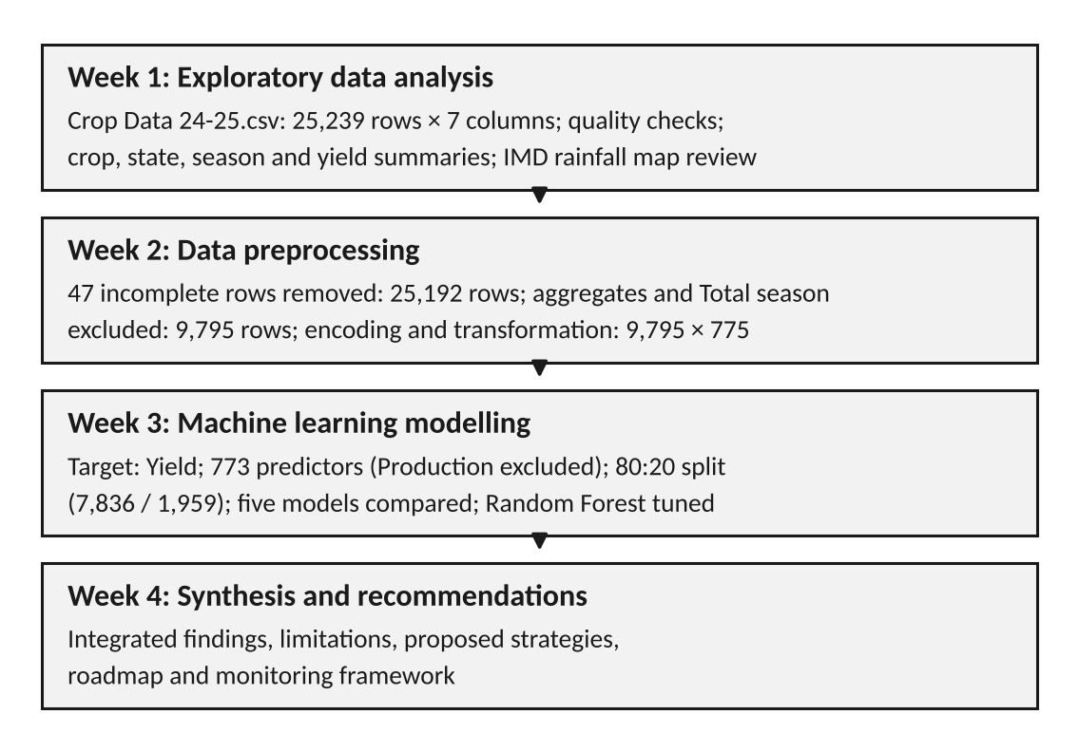
Figure 1. Workflow of the four-week project, with record counts at each stage.
Table 1. Data dimensions through the project
Stage | Rows | Columns | Description
Raw dataset (Week 1) | 25,239 | 7 | Original file; 47 records with missing Production and Yield
Cleaned dataset (Week 2) | 25,192 | 7 | 47 incomplete records removed; aggregates and Total season retained
Modelling subset (Week 2) | 9,795 | 7 | Aggregate crop categories and Total season excluded
Feature matrix (Week 2) | 9,795 | 775 | 772 one-hot columns and 3 standardized numerical columns
Model inputs (Week 3) | 9,795 | 773 predictors | Production excluded; Yield as target; 7,836 training and 1,959 test records

3.2 Tools
The analysis was carried out in Python using Google Colab. The pandas library was used for data handling (pandas development team, n.d.), NumPy for numerical transformation (NumPy developers, n.d.), Matplotlib for charts (Matplotlib development team, n.d.) and scikit-learn for preprocessing, modelling and evaluation (Pedregosa et al., 2011). The Week 2 and Week 3 workflows were run in Google Colab notebooks (Vyahalkar, n.d.-a, n.d.-b).

3.3 Data source and provenance
The analysed file, Crop Data 24-25.csv (Crop Data 24-25.csv, n.d.), was supplied for the project. It records, for each state, district, crop and season, the area, production and yield for 2024-25. A file with the same name and header is listed on the Global Agriculture (Krishak Jagat) website, where it is credited to the Department of Agriculture and Farmers Welfare (DA&FW) (Global Agriculture, n.d.). In the Week 2 check, all 27 Punjab rows compared matched exactly. That page is a secondary publisher, and the original government portal was not located. The primary source, the publication date, the units (area in lakh hectares, production in lakh tonnes and yield in kg/ha, as stated on the hosting page) and the equivalence of the complete file are therefore not independently verified.

4. Week 1 Summary: Exploratory Data Analysis

4.1 Dataset and data quality
The raw dataset has 25,239 rows and 7 columns: State, District, Crop and Season (categorical) and Area-2024-25, Production-2024-25 and Yield-2024-25 (numerical). It contains 31 state and union-territory labels, 723 district-name strings, 19 crop categories and four season labels (Total, Kharif, Rabi and Summer). Production and Yield each have 47 missing values, occurring in the same records, and no other column has missing values. There are no exact duplicate rows.
Two features of the data affect every later analysis. First, the Crop column mixes individual crops with aggregate categories such as Total Food Grains and Cereals, so summing the column counts the same output more than once. Second, the Season label Total is an aggregate of the other three. The 723 district strings were not checked against an authoritative list of districts.

4.2 Crop, state, district and seasonal patterns
For the exploratory summaries, an analysis copy was created that excluded three aggregate categories (Total Food Grains, Cereals and Nutri/Coarse Cereals), leaving 17,823 records. In this copy, Uttar Pradesh (1,333.60 lakh tonnes) and Madhya Pradesh (1,006.27 lakh tonnes) had the highest recorded production, followed by Rajasthan, Punjab and Maharashtra (Figure 2a). By season, Kharif recorded 1,822.67 lakh tonnes, Rabi 1,710.57 and Summer 201.42.
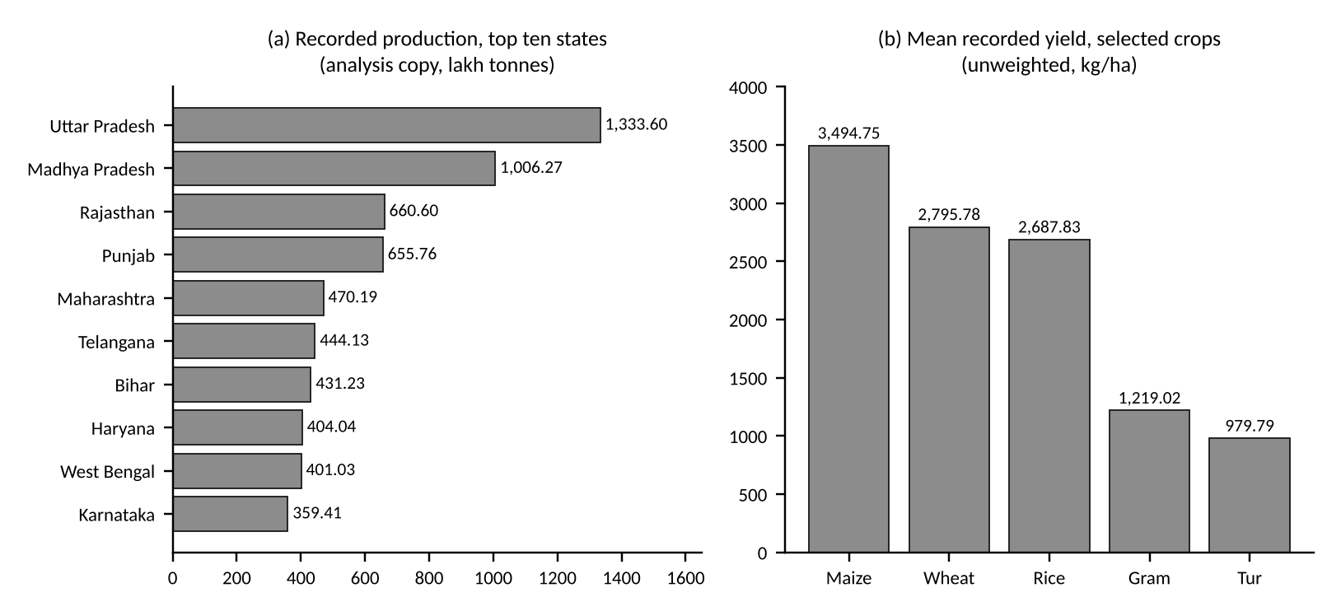
Figure 2. Week 1 results: (a) top ten states by recorded production and (b) mean recorded yield for five selected crops. Values are exploratory and unweighted.
District-level information was not analysed separately in Week 1. Mean recorded yield differed widely between crops (Table 2 and Figure 2b): Maize averaged 3,494.75 kg/ha and Tur 979.79 kg/ha. These are unweighted averages across district-season records, so a district with a very small area contributes as much as one with a large area.
Table 2. Recorded yield for selected crops (Week 1; unweighted record-level values, kg/ha)
Crop | Records | Mean yield | Median yield
Maize | 2,026 | 3,494.75 | 3,177.50
Wheat | 1,062 | 2,795.78 | 2,790.00
Rice | 1,792 | 2,687.83 | 2,698.50
Gram | 1,014 | 1,219.02 | 1,216.00
Tur | 1,040 | 979.79 | 935.50
The state and season totals should be read as exploratory rankings. The analysis copy removed only three aggregate categories, and Week 2 later identified a fourth aggregate (Total Pulses) and showed that Total-season rows repeat the seasonal rows. The totals are therefore not official production figures.

4.3 Area, production and yield
Across 10,134 records with positive area and non-negative production, the Pearson correlation between area and production was approximately 0.823. This is expected, since production is the product of area and yield, but the coefficient pools different crops, seasons and regions and does not indicate causation.

4.4 Rainfall context
Monthly and seasonal rainfall maps for the 2024 south-west monsoon, published by the India Meteorological Department (2024b), were reviewed. They show that rainfall departures from normal were uneven across regions and changed from month to month. The India Meteorological Department also publishes a monsoon report for 2024 (India Meteorological Department, 2024a), but no statistics were extracted from it for this project. The maps exist only as images, and no numerical rainfall data were joined to the crop records. The review was therefore qualitative, and no relationship between rainfall and yield was measured.

5. Week 2 Summary: Data Preprocessing

5.1 Missing values
The 47 records with missing Production and Yield had an Area of 0.00 in 43 cases and between 0.04 and 0.05 in the other four; Chhattisgarh (14 records) and Rajasthan (11) accounted for 25 of them. Imputation would have created production and yield values for which the source gives no basis, and treating the blanks as zero would have asserted a harvest outcome that the source does not state. The 47 records (0.19% of the dataset) were therefore removed, giving a cleaned dataset of 25,192 rows with no missing values.

5.2 Outlier analysis
Outliers were screened with the interquartile-range (IQR) method (Table 3). The high flag rates for Area and Production arise because the lower quartile of both variables is zero and their medians are 0.02 and 0.03, so the upper fences are very low; they do not indicate that a large share of values is erroneous. The largest Area and Production values are district totals for aggregate crops, and the largest Yield values, such as 15,033 kg/ha for Other Pulses in Bikaner, occur on records whose Area and Production are 0.00 or 0.01 and are probably unreliable. After investigation, no observation was removed as an outlier.
Table 3. IQR outlier screening of the cleaned dataset (n = 25,192)
Variable | Upper bound | Values flagged | Share
Area-2024-25 | 0.725 | 3,903 | 15.49%
Production-2024-25 | 1.500 | 4,299 | 17.06%
Yield-2024-25 | 5,630.875 | 485 | 1.93%

5.3 Filtering to a modelling subset
Of the 25,192 cleaned records, 8,113 belong to four aggregate categories (Total Food Grains, Cereals, Nutri/Coarse Cereals and Total Pulses) and 10,143 carry the Total season. For individual crops, Area and Production in the Total-season rows agree with the sum of the Kharif, Rabi and Summer rows to within 0.02, so they duplicate seasonal information. Excluding both groups removed 15,397 records and left a modelling subset of 9,795 observations, each representing one individual crop in one season in one district, covering 31 states, 723 districts, 15 crops and three seasons. The excluded records are valid data; they were set aside because they overlap with the retained records.

5.4 Encoding and transformation
State, District, Crop and Season were converted to 772 binary columns with one-hot encoding (scikit-learn developers, n.d.-j). Area, Production and Yield were transformed with log1p (NumPy developers, n.d.), which reduced their skewness (Area from 4.9450 to 3.0746, Production from 5.0871 to 2.9391 and Yield from 1.8942 to -0.9452). They were then standardized to zero mean and unit variance (scikit-learn developers, n.d.-k). Area and Production remain right-skewed because 46.7% of modelling records have an Area of exactly 0.00. The final matrix has 9,795 rows and 775 columns and contains no missing values, infinite values or duplicate rows.

5.5 Limitations of the preprocessing
The encoder and scalers were fitted on all 9,795 records before the data were divided into training and test sets. The standardization parameters therefore contain information from records that were later used for testing. This is a form of data leakage (scikit-learn developers, n.d.-a). A corrected evaluation would fit all learned preprocessing on the training data only, preferably inside a pipeline (scikit-learn developers, n.d.-e). Other limitations are that the 13 zero-yield records lie far below other values after the log transformation, that spelling variants of district names were not examined beyond case and whitespace, and that the units are not confirmed at the primary source.

6. Week 3 Summary: Machine Learning Modelling

6.1 Problem formulation
The task was to estimate crop yield from crop, location, season and planted area. The target variable was the standardized log-transformed Yield, and the 773 predictors were the 772 one-hot columns for State, District, Crop and Season together with the standardized Area. Production was excluded because Yield is computed from Production and Area, so including it would let a model recover the target almost directly (target leakage). Predictors were selected on domain grounds and no automatic feature-selection method was applied.

6.2 Train-test split
The data were divided 80:20 at random (random_state = 42) into 7,836 training and 1,959 test records, and every model was evaluated on the same test set. Because the split is random, records from the same district appear in both sets; only one of the 1,959 test records belongs to a district absent from training. The test results therefore describe estimation for combinations similar to those already seen, and not performance on a future year or on new districts.

6.3 Models and evaluation metrics
Five models were compared: a Dummy Regressor that predicts the training mean (scikit-learn developers, n.d.-f), Linear Regression (scikit-learn developers, n.d.-h; Hastie et al., 2009), a Decision Tree (scikit-learn developers, n.d.-l; Breiman et al., 1984), a Random Forest with preset parameters (scikit-learn developers, n.d.-g; Breiman, 2001) and a tuned Random Forest. Performance was measured by mean absolute error (MAE), root mean squared error (RMSE) and the coefficient of determination (R²) (scikit-learn developers, n.d.-c). MAE and RMSE are expressed in standardized yield units, not kg/ha. R² is the proportion of variance in the standardized test target that the model explains relative to predicting the mean; it is not an accuracy percentage and can be negative.
Table 4. Test-set performance of the five models (standardized yield units; 1,959 test records)
Model | MAE | RMSE | R²
Dummy Regressor | 0.7902 | 0.9891 | -0.0010
Linear Regression | 0.4308 | 0.6296 | 0.5944
Decision Tree | 0.3870 | 0.5986 | 0.6333
Random Forest | 0.5442 | 0.7352 | 0.4469
Tuned Random Forest | 0.2632 | 0.4592 | 0.7843
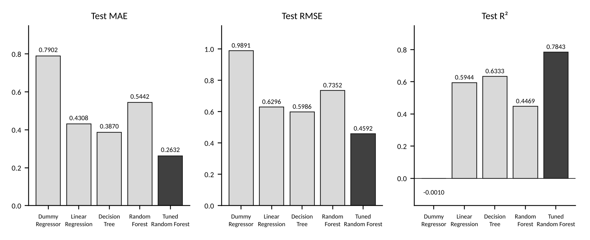
Figure 3. Test-set MAE, RMSE and R² for the five models (values as in Table 4).
The tuned Random Forest had the lowest error and the highest R² (Table 4 and Figure 3). The preset Random Forest performed worse than the single Decision Tree. A likely reason is that its max_features setting lets each split consider only a small subset of the 773 features, but this explanation was not tested directly.

6.4 Hyperparameter tuning
Hyperparameters were searched with randomized search (Bergstra & Bengio, 2012; scikit-learn developers, n.d.-i). Six of 216 possible configurations were sampled and scored with three-fold cross-validation on the training data only (scikit-learn developers, n.d.-b), a total of 18 model fits. The best configuration, with a cross-validation RMSE of approximately 0.5143, used n_estimators = 50, max_depth = None, min_samples_split = 5, min_samples_leaf = 2 and max_features = 0.5, and it was refitted on all training records. Only six configurations were evaluated, so the selected model is the best of those sampled and not necessarily the best available.

6.5 Training and test performance
The tuned model obtained MAE 0.2165, RMSE 0.4126 and R² 0.8307 on the training set, compared with 0.2632, 0.4592 and 0.7843 on the test set. The test RMSE is about 11% higher than the training RMSE, which indicates moderate overfitting. Test errors were centred close to zero (mean 0.0015), and about 96.6% of test estimates fell within one standardized unit of the reported value.

6.6 Feature importance
Figure 4 shows the 15 most important features of the tuned model. The largest values were Crop_Maize (0.2232), Crop_Rice (0.1197), Crop_Moong (0.0819), Area (0.0704), Crop_Wheat (0.0611) and Crop_Urad (0.0464); together these six features account for approximately 60% of the total importance (their sum is 0.6027). A further 151 of the 773 features have exactly zero importance. No District feature appears among the top 15.
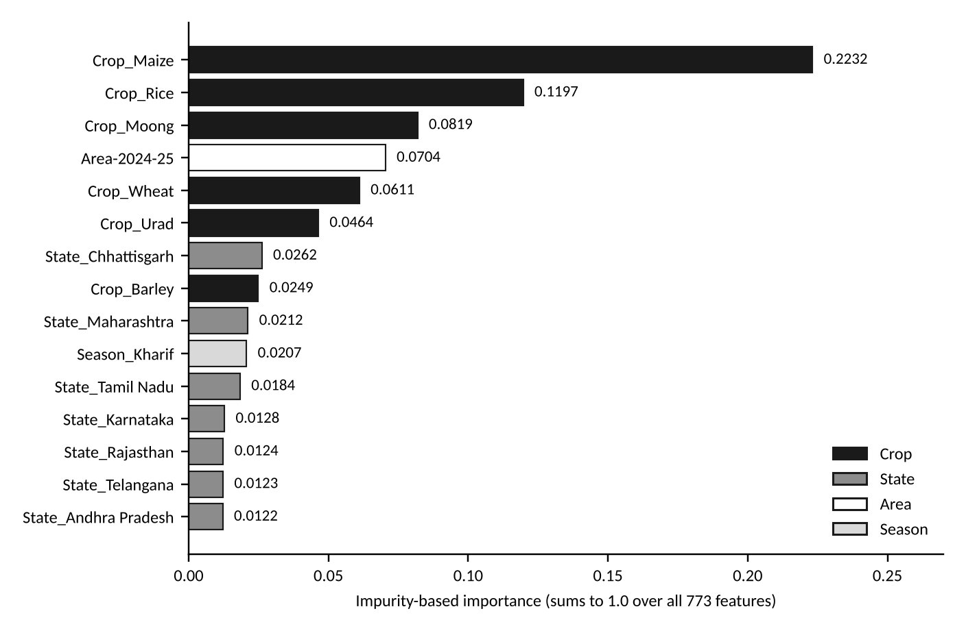
Figure 4. The 15 most important features of the tuned Random Forest (impurity-based importance).
Feature importance describes how the fitted model uses its inputs. It does not show that growing a particular crop, or farming in a particular state, raises yield. Impurity-based importance also favours features with many possible split points and was calculated on training data (Strobl et al., 2007); permutation importance on held-out data (scikit-learn developers, n.d.-d) was not computed.

6.7 Error analysis and limitations
Errors were concentrated in a small number of unusual records. Two test records with a reported Yield of zero contributed 24.6% of the total squared error; without them the test RMSE would have been 0.3988 and R² 0.8230, although they were retained in all reported results. The largest errors in original units were underestimates of very high yields recorded on very small areas, which are the records already identified in Week 2 as probably unreliable.
The Week 3 results are subject to the limitations set out in Chapter 12. In particular, preprocessing was fitted before the split, the split was random, and the data cover a single year. The results demonstrate that the tuned model reproduces much of the same-season pattern in held-out records. They do not demonstrate forecasting of future seasons, performance in unseen districts, or usefulness for farm-level decisions.

7. Integrated Findings and Interpretation
Table 5 brings together the main findings of the three weeks and indicates whether each is an observation or an interpretation. The interpretations are plausible readings of the observations and were not tested in the project.
Table 5. Integrated findings of Weeks 1 to 3
Finding | Type | Basis
Mean recorded yield varies widely between crops (Maize 3,494.75 kg/ha; Tur 979.79 kg/ha). | Observed | Week 1
Area and production are strongly correlated (r ≈ 0.823, n = 10,134). | Observed | Week 1
The source file mixes aggregate and individual crops, and the Total season repeats the seasonal records. | Observed | Weeks 1 and 2
Many small plantings have Area and Production of 0.00 while yield is positive; the largest yields occur on such records. | Observed | Weeks 2 and 3
The tuned Random Forest estimates standardized yield on held-out records better than the baseline and the other models (R² 0.7843, RMSE 0.4592). | Observed (single random split) | Week 3
Crop indicators and Area dominate the model; no District feature is among the 15 most important. | Observed | Week 3
Crop identity accounts for much of the recorded variation, so yield benchmarks should be crop-specific. | Interpretation | Weeks 1 and 3
Variation within a crop that the model does not capture may be related to conditions not in the dataset, such as soil, water, inputs and weather. | Interpretation (untested) | Week 3
The model's largest errors reflect records whose source values are weak, as well as limits of the model. | Interpretation | Weeks 2 and 3
Three points follow. First, the data are sufficient for transparent descriptive benchmarks by crop, season and region, provided that aggregate records are separated and extreme records are flagged. Second, a model using only crop, location, season and area reproduces much of the same-season pattern, but a large part of this comes from differences between crops that a benchmark table would also show; whether the model adds anything beyond such simple benchmarks was not tested. Third, the factors that an agribusiness can influence directly, such as water, nutrients, seed, timing and operations, are absent from the data, so recommendations about them cannot be derived from this project and need additional data and a properly designed trial.

8. Agricultural and Agribusiness Challenges
The project findings point to five challenges that an agribusiness would face in using district-level statistics for planning.
- Reliability and comparability of statistics. Overlapping categories, rounding to two decimals and unverified units make it easy to double count or to misread yields. Yields computed from areas below the reporting precision are unreliable.
- Limited explanatory information. Crop, location, season and area leave a substantial part of the variation unexplained (the tuned model's test R² is 0.7843), and the dataset holds no information on the factors that farm management can change.
- Absence of resource and operational data. Water, soil, fertiliser, seed, labour and machinery information was not available, so the project could not assess how resources are used.
- Absence of market and logistics data. Prices, arrivals, storage and transport were not part of the dataset, so production figures cannot be linked to procurement or supply-chain planning.
- Limited readiness for predictive use. The existing model was evaluated on a single year with a random split and preprocessing fitted before the split, so its value for planning future seasons is unknown.

9. Strategic Recommendations

9.1 Approach
The ten recommendations below follow from the challenges in Chapter 8. Each is presented in the same way: the problem it addresses; its basis in the project, separating observed findings (O), interpretations (I) and the proposal (P); the proposed action; the additional data required; a KPI by which it could be monitored; and the main risks. All proposed actions are recommendations for future implementation. None was tested in this project, and no improvement in yield, cost, income or supply-chain performance is claimed. Only the strategies in Sections 9.3, 9.4 and 9.11 can begin with the data already held; the others depend on new data.

9.2 Crop planning and crop selection
Problem addressed. Crop planning needs comparable yield information by crop and season, but headline statistics combine aggregate and individual categories and give no indication of cost, price or risk.
Basis in the project. O: mean recorded yield ranged from 3,494.75 kg/ha (Maize) to 979.79 kg/ha (Tur), and crop indicators were the most important model features. I: yield benchmarks should be crop-specific. P: use them as one input to planning. The project does not show that changing crop would raise yield.
Proposed action. Prepare district-season benchmark tables for individual crops (area-weighted yield, median, quartiles and number of records) from non-overlapping records, and review them with agronomists together with cost and price information.
Additional data required. Multi-year district-crop-season records; cost of cultivation; prices; water availability; soil suitability.
KPI. Area-weighted yield by crop, district and season relative to the peer median; net return per hectare once cost and price data are available.
Risks and limitations. Higher yield does not imply higher profit; one year of data cannot show trends; agro-climatic suitability is not in the data.

9.3 District-level yield monitoring
Problem addressed. Yield figures are easily misread because of overlapping categories, unweighted averages and very small areas, and district-level comparisons were not produced in Weeks 1 to 3.
Basis in the project. O: 47 records were incomplete; 13 records in the modelling subset have zero yield; the highest yields occur on records with Area of 0.00 or 0.01; the model's largest errors fall on such records. I: some recorded yields on very small areas are unreliable. P: monitor yields with explicit quality flags.
Proposed action. Build crop-by-district-by-season monitoring tables with area-weighted yield and record counts, and flag zero yields, tiny areas, extreme yield-to-peer ratios and missing values for review against the original source records.
Additional data required. The cleaned dataset with aggregate and Total-season flags; confirmed units and category hierarchy; several years of records.
KPI. Share of records passing validation checks; number of flagged records and the proportion resolved.
Risks and limitations. Rounding limits the reliability of small-area yields; reporting may lag; districts with different agro-climatic conditions may not be comparable; a low yield alone does not indicate poor management.

9.4 Agricultural data dashboards
Problem addressed. Results are held in separate notebooks and reports, and nothing signals which figures are observed, estimated or assumed.
Basis in the project. O: Weeks 1 to 3 produced tables and charts for data quality, crop performance and model results. I: a single view would help readers separate evidence types. P: build an analyst dashboard.
Proposed action. Develop a dashboard with views for data quality, crop and district performance, yield exceptions and model evaluation, each showing source, units and validation status, and extend it to weather and resource data as they become available. Model views should state the validation design and its limitations prominently.
Additional data required. The datasets above, with metadata on source, date, units and refresh.
KPI. Time taken to produce a standard report; proportion of flagged records reviewed.
Risks and limitations. A dashboard can create false confidence if warnings are ignored; it needs maintenance, training and refresh rules.

9.5 Soil-health information
Problem addressed. Location labels are too coarse to represent soil differences within a district.
Basis in the project. O: the model used no soil variable, and no District feature was among its 15 most important features. I: part of the unexplained variation within crops may relate to soil, but this was not tested. P: collect soil information and test whether it improves estimates.
Proposed action. Collect plot-level soil test results (for example pH, organic carbon, nutrients and salinity) linked to crop and yield records, and test whether they improve held-out estimates. Any soil-based recommendation should follow established agronomic guidance.
Additional data required. Geo-referenced soil test reports, soil maps, plot-level yield and crop history.
KPI. Proportion of pilot plots with linked soil tests; change in held-out MAE and RMSE when soil variables are added.
Risks and limitations. Testing is costly, laboratory results vary, soil changes over time, and farm data raise privacy concerns.

9.6 Weather-based planning
Problem addressed. Rainfall and temperature plausibly influence yield, but the project contains no numerical weather information.
Basis in the project. O: the IMD maps (India Meteorological Department, 2024b) show uneven monsoon rainfall in 2024, and no numerical rainfall was joined to the crop records. I: rainfall may matter for rainfed crops. P: acquire weather data and test its contribution.
Proposed action. Obtain numerical district-level rainfall and temperature aligned to crop calendars, derive seasonal features such as cumulative rainfall and dry spells, test whether they improve estimates over the Week 3 baseline, and use them to prepare a watch-list of districts for expert review.
Additional data required. Daily or weekly rainfall and temperature series; sowing dates; multi-year yields.
KPI. Share of district-seasons with matched weather data; change in validation RMSE when weather features are added.
Risks and limitations. Spatial mismatch between weather grids and districts; irrigated and rainfed areas respond differently; one year of data invites spurious relationships.

9.7 Irrigation and water management
Problem addressed. Without irrigation and water-use data, neither water productivity nor over- or under-irrigation can be assessed.
Basis in the project. O: the dataset has no irrigation variable, and rainfall maps cannot show the water a crop receives. I: yield differences between irrigated and rainfed areas may be large, as noted in Week 1, but were not examined. P: establish a measured water-use baseline.
Proposed action. At pilot sites, record water applied per plot and season and compute yield per unit of water; then compare water-saving practices with a baseline in a controlled pilot.
Additional data required. Irrigated area by source; groundwater and canal information; pump-hours or metered volumes; soil moisture.
KPI. Water consumption per hectare; yield per unit of water.
Risks and limitations. Local hydrology and regulations limit what is possible, measurement is costly, and results at one site may not transfer.

9.8 Fertiliser and seed planning
Problem addressed. Input choices cannot be linked to yield outcomes with the present data.
Basis in the project. O: no input variables were available, and the tuned model leaves part of the yield variation unexplained. I: input practices may account for some of it. P: record inputs systematically.
Proposed action. Create an input register (variety, sowing date, fertiliser type, dose and timing) linked to plots, soil tests and yields, to calculate input cost and to plan procurement from approved crop-area plans. Doses and varieties should come from agronomic guidance, not from the project model.
Additional data required. Plot-level input records; variety details; sowing and harvest dates; input prices.
KPI. Input cost per hectare and per tonne.
Risks and limitations. Variety suitability is location-specific, and recording burdens can reduce data quality.

9.9 Machinery and labour allocation
Problem addressed. Sowing and harvesting create seasonal peaks in demand for labour and machinery, but no operations data exist in the project.
Basis in the project. O: recorded production in Kharif and Rabi was of similar size (1,822.67 and 1,710.57 lakh tonnes), and Summer was much smaller (201.42), in the exploratory analysis. I: workloads probably differ by season, but this is an indirect inference. P: build a workload calendar.
Proposed action. Combine crop-area plans with operation windows and labour and machine norms to estimate labour-days and machine-hours needed per district and week, and compare them with available capacity.
Additional data required. Operation windows; labour and machine norms; fleet and labour availability; weather-workability days.
KPI. Machine utilisation; operation delay days; labour-days per hectare.
Risks and limitations. Norms vary by field and farmer, weather shifts timing, and labour data may be informal; changes in scheduling affect workers and need fair handling.

9.10 Procurement and supply-chain planning
Problem addressed. Procurement volumes and storage use depend on expected output and market conditions, which this dataset does not cover.
Basis in the project. O: the dataset contains production values but no price, arrival, storage or transport data, and the Week 3 model estimates same-season held-out records only. P: develop a volume-planning approach and test it retrospectively.
Proposed action. Back-test benchmark-based volume estimates (area multiplied by benchmark yield, with an uncertainty range) against actual procurement records, then add price and logistics data and pilot the approach for one commodity.
Additional data required. Mandi prices and arrivals; procurement and storage records; transport costs; post-harvest losses.
KPI. Difference between planned and actual procured volume; storage utilisation; post-harvest loss.
Risks and limitations. Yield estimation error carries into volume planning, and price changes may outweigh yield effects. Commitments should not rest on model output alone.

9.11 Predictive analytics
Problem addressed. The existing model has not been shown to forecast future seasons or unseen districts.
Basis in the project. O: the model was evaluated on a random split, with preprocessing fitted before the split, on one year of data. I: its test results are probably somewhat optimistic. P: re-evaluate it under a stricter design.
Proposed action. Rebuild the Week 3 experiment as a pipeline that fits encoders and scalers on training data only (scikit-learn developers, n.d.-e); validate on a later year and on held-out districts; compare against simple benchmarks such as peer medians; add uncertainty ranges and permutation importance; add new features one at a time.
Additional data required. Several years of consistent district-crop-season data; weather and other variables when available.
KPI. MAE, RMSE and R² on future-year and district-held-out data, reported against baselines and by crop and region.
Risks and limitations. A re-evaluated model still reflects the data it sees; errors will remain at unusual records; zero-yield records should be verified and not removed to improve metrics.

10. Proposed Implementation Roadmap
Table 6 sets out a sequence of five phases. It is proposed, not scheduled: no durations or budgets are suggested, because the project provides no basis for them. Each phase would end with a review of its outputs before the next begins. Phases 1 and 2 use only data already held.
Table 6. Proposed implementation phases
Phase | Main activities | Outputs | Completion criteria
1. Data validation | Confirm the primary source, units and category hierarchy; verify zero-yield and extreme records; document cleaning rules | Data specification; validated cleaned dataset | Specification agreed; cleaning reproducible
2. Model re-evaluation | Fit preprocessing on training data only; temporal and district-grouped validation; compare with simple benchmarks; permutation importance | Corrected evaluation; error analysis by crop and region | Validation design and results documented
3. Data integration | Acquire and align weather, soil, irrigation, input and market data; test the added value of each source | Integrated dataset; coverage report | Join logic documented; coverage assessed
4. Dashboard and pilot | Build the analyst dashboard; run a limited pilot with a baseline and comparison group | Pilot dashboard; pilot protocol and results | Baseline recorded; outcomes measured against comparison
5. Review | Assess errors, data revisions and user feedback; decide whether to extend | Review report | Documented decision on wider use

11. Proposed Monitoring Framework and KPIs

11.1 Principles
A KPI is useful only if it is measured against a baseline. For outcomes such as yield, water use or return, a baseline period of at least one season and, where possible, a comparison group of plots or districts are needed, so that seasonal variation is not mistaken for the effect of a change. Model indicators describe estimation quality and not agricultural impact. Table 7 lists the indicators proposed in Chapter 9.

11.2 Indicators
Table 7. Proposed KPIs and their measurement
KPI | Definition and measurement | Baseline in the project data
Crop yield per hectare | Total production divided by total area for each crop, district and season, reported with the median and quartiles of record-level yield | Record-level yield available; only unweighted means were calculated in Week 1
Water consumption per hectare | Water applied (metered volume or pump-hours multiplied by discharge) divided by cultivated area, per crop season | Not available
Fertiliser and input costs | Seed, fertiliser and crop-protection cost per hectare and per tonne, from purchase and issue records | Not available
Agricultural productivity | Production per hectare, per labour-day and per unit of water | Production per hectare derivable; others not available
Operational costs | Labour, machinery, transport, storage and handling cost per tonne handled | Not available
Net return per hectare | Revenue (quantity sold multiplied by realised price) minus total cultivation cost, divided by area | Not available
Data quality | Share of records passing validation; number of unresolved flagged records | Counts of missing and zero-yield records available (47 and 13)
Model MAE and RMSE | Mean absolute error and root mean squared error on future-year and district-held-out data, with baseline and by crop and region | Test MAE 0.2632 and RMSE 0.4592 (random split; standardized units)
Model R² | One minus the ratio of the model's squared error to that of predicting the mean; not an accuracy percentage | Test R² 0.7843 (random split)
The Week 3 model values are reference points from a random split with preprocessing fitted before the split. They are not comparable with results from a corrected, future-year validation and should be recalculated under that design.

11.3 Oversight
Model output should inform, and not replace, the judgement of agronomists and managers. Decisions affecting farmers, such as input advice, crop changes or procurement commitments, should have a named reviewer, a recorded rationale and the possibility of override. Farm and plot data should be collected with the consent of the farmers concerned and protected.

12. Limitations
The limitations below apply to the work as a whole. Table 8 lists them. They should be read together with the findings in Chapter 7, since each restricts how far the findings can be generalised.
Table 8. Limitations of the project and how future work could address them
Limitation | Consequence | How it could be addressed
Preprocessing (one-hot encoding, log1p and standardization) was fitted on all 9,795 records before the train-test split | Test records influenced the preprocessing, so the test results may be somewhat optimistic by an unmeasured amount | Fit all preprocessing on training data only, in a pipeline (scikit-learn developers, n.d.-a, n.d.-e)
Evaluation used a random split | Test records resemble training records; performance on a future year or unseen district is unknown | Temporal and district-grouped validation
Data cover one agricultural year (2024-25) | Year-to-year variation and trends cannot be examined | Add further years
No weather, soil, irrigation, fertiliser, seed, labour or market variables | Drivers of yield that can be managed are not represented | Integrate and test additional data sources
Feature importance is not causal | Importance values show model reliance and cannot support claims that a crop or location causes higher yield | Permutation importance and, for causal questions, designed trials
The model has not been validated for farm-level recommendations | It cannot guide decisions for individual farms or plots | Plot-level data and pilot testing
Results do not establish reliable future yield prediction | The model must not be used as a forecasting system | Multi-year validation with uncertainty estimates
Data quality and provenance: overlapping categories, rounding, unverified units and secondary source (Global Agriculture, n.d.) | Totals and extreme yields may be misleading | Verify the primary source; maintain an exception log
In addition, the tuned model overfits moderately (training R² 0.8307 against test R² 0.7843), only six hyperparameter configurations were evaluated, and results come from one random seed, so no estimate of uncertainty in the test metrics is available.

13. Future Scope
- Confirm the primary data source and units, and verify zero-yield and extreme records against original records.
- Repeat the modelling with a leakage-controlled pipeline, repeated cross-validation, a broader hyperparameter search, and temporal and district-grouped validation, comparing results with simple benchmarks.
- Add further years and verified weather, soil, irrigation, input, operations and market data, and test the contribution of each.
- Use permutation importance on held-out data and, where a causal question is of interest, a designed field comparison.
- Run a limited, comparison-based pilot of yield monitoring and the dashboard before any wider use.

14. Conclusion
Over four weeks the project progressed from a raw district-level crop file to a documented preparation process, a comparison of yield models, and a set of proposed strategies for agribusiness use. The exploratory analysis showed that recorded yield differs strongly between crops and that area scales production. After preprocessing, a tuned Random Forest estimated standardized yield on held-out records with test MAE 0.2632, RMSE 0.4592 and R² 0.7843, clearly better than the baseline, with crop identity and area the most influential inputs.
The work also defines its own limits. Preprocessing was fitted before the split, the evaluation used a random split on a single year, errors were concentrated at a few unusual records, and no weather, soil, water, input or market data were available. The results therefore support descriptive benchmarking and further study, but not forecasting or farm-level recommendations. The strategies in Chapter 9 are proposals for staged testing: the nearest steps are to validate the data, to repeat the model evaluation correctly, and to prototype yield monitoring and a dashboard from the data already held. Any benefit to yield, cost or income would have to be demonstrated in a pilot measured against a baseline.

References
Academic and research publications
- Bergstra, J., & Bengio, Y. (2012). Random search for hyper-parameter optimization. Journal of Machine Learning Research, 13, 281-305.
- Breiman, L. (2001). Random forests. Machine Learning, 45(1), 5-32.
- Breiman, L., Friedman, J. H., Olshen, R. A., & Stone, C. J. (1984). Classification and regression trees. Wadsworth.
- Hastie, T., Tibshirani, R., & Friedman, J. (2009). The elements of statistical learning (2nd ed.). Springer.
- Pedregosa, F., Varoquaux, G., Gramfort, A., Michel, V., Thirion, B., Grisel, O., Blondel, M., Prettenhofer, P., Weiss, R., Dubourg, V., Vanderplas, J., Passos, A., Cournapeau, D., Brucher, M., Perrot, M., & Duchesnay, E. (2011). Scikit-learn: Machine learning in Python. Journal of Machine Learning Research, 12, 2825-2830.
- Strobl, C., Boulesteix, A.-L., Zeileis, A., & Hothorn, T. (2007). Bias in random forest variable importance measures: Illustrations, sources and a solution. BMC Bioinformatics, 8, Article 25.
Government and institutional sources
- India Meteorological Department. (2024a). Monsoon report 2024 [Report]. Ministry of Earth Sciences, Government of India. https://mausam.imd.gov.in/imd_latest/monsoonreport2024.pdf
- India Meteorological Department. (2024b). South-West Monsoon Season 2024 [Web page with rainfall maps]. Ministry of Earth Sciences, Government of India. https://imdpune.gov.in/swmonsoon24.php
Software documentation
- Matplotlib development team. (n.d.). Matplotlib documentation. https://matplotlib.org/stable/
- NumPy developers. (n.d.). numpy.log1p. https://numpy.org/doc/stable/reference/generated/numpy.log1p.html
- pandas development team. (n.d.). pandas documentation. https://pandas.pydata.org/docs/
- scikit-learn developers. (n.d.-a). Common pitfalls and recommended practices [Data leakage]. https://scikit-learn.org/stable/common_pitfalls.html
- scikit-learn developers. (n.d.-b). Cross-validation: Evaluating estimator performance. https://scikit-learn.org/stable/modules/cross_validation.html
- scikit-learn developers. (n.d.-c). Metrics and scoring: Quantifying the quality of predictions. https://scikit-learn.org/stable/modules/model_evaluation.html
- scikit-learn developers. (n.d.-d). Permutation feature importance. https://scikit-learn.org/stable/modules/permutation_importance.html
- scikit-learn developers. (n.d.-e). Pipelines and composite estimators. https://scikit-learn.org/stable/modules/compose.html
- scikit-learn developers. (n.d.-f). sklearn.dummy.DummyRegressor. https://scikit-learn.org/stable/modules/generated/sklearn.dummy.DummyRegressor.html
- scikit-learn developers. (n.d.-g). sklearn.ensemble.RandomForestRegressor. https://scikit-learn.org/stable/modules/generated/sklearn.ensemble.RandomForestRegressor.html
- scikit-learn developers. (n.d.-h). sklearn.linear_model.LinearRegression. https://scikit-learn.org/stable/modules/generated/sklearn.linear_model.LinearRegression.html
- scikit-learn developers. (n.d.-i). sklearn.model_selection.RandomizedSearchCV. https://scikit-learn.org/stable/modules/generated/sklearn.model_selection.RandomizedSearchCV.html
- scikit-learn developers. (n.d.-j). sklearn.preprocessing.OneHotEncoder. https://scikit-learn.org/stable/modules/generated/sklearn.preprocessing.OneHotEncoder.html
- scikit-learn developers. (n.d.-k). sklearn.preprocessing.StandardScaler. https://scikit-learn.org/stable/modules/generated/sklearn.preprocessing.StandardScaler.html
- scikit-learn developers. (n.d.-l). sklearn.tree.DecisionTreeRegressor. https://scikit-learn.org/stable/modules/generated/sklearn.tree.DecisionTreeRegressor.html
Project data and technical materials
- Crop Data 24-25.csv. (n.d.). District-level crop area, production and yield, 2024-25 [Data set]. Supplied for the Yuva Intern project.
- Global Agriculture (Krishak Jagat). (n.d.). Latest agriculture statistics of India: All India: District and crop wise area, production & yield of all crops (2024-25) [Data file DES-District-Data-For-2024-25.csv; source credited to DA&FW]. Retrieved October 25, 2026, from https://www.global-agriculture.com/latest-agriculture-statistics-of-india/

